CHIRPS Version Comparison Report: v2.0 to v3.0
Analysis Period: Full Year 2020 (January - December)
Geographic Coverage: -35°S to 20°N, -20°W to 50°E

- Grid Cell Coverage and Resolution

- Total Grid Cells Analyzed: 1,540,000 cells
- Grid Dimensions: 1,100 latitude points × 1,400 longitude points
- Spatial Resolution: 0.05° (~5.5 km at the equator)
- Geographic Extent:
  - Latitude: 35°S to 20°N (spanning 55 degrees)
  - Longitude: 20°W to 50°E (spanning 70 degrees)
- Data Completeness: 100% valid data coverage (no missing cells)

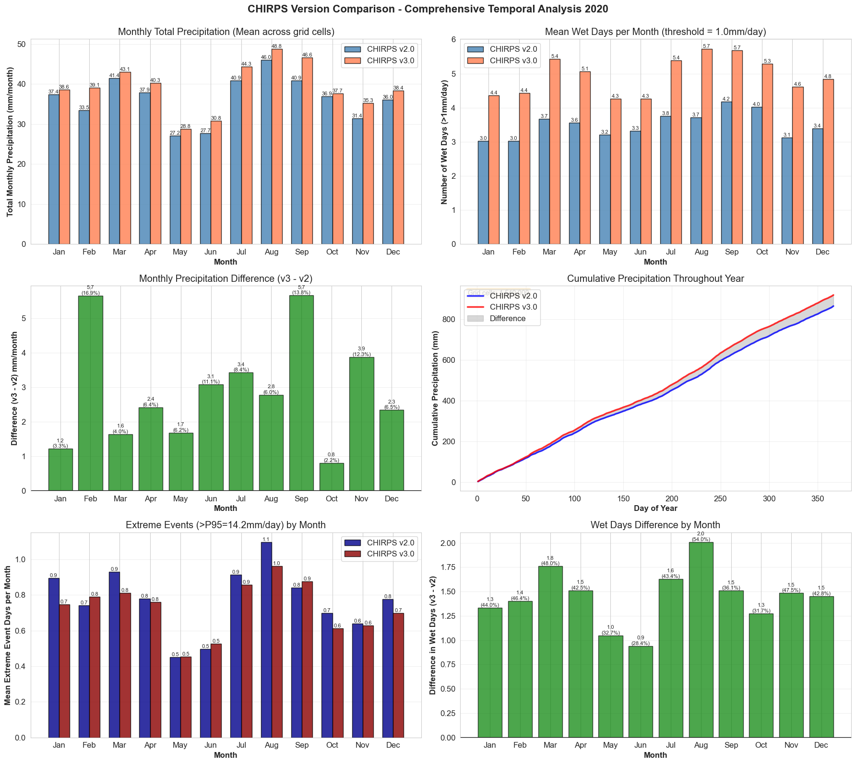

2. Annual Overview: The Big Picture

Overall Precipitation Totals
Metric | CHIRPS v2.0 | CHIRPS v3.0 | Difference | % Change
Annual Mean | 437.2 mm | 471.8 mm | +34.6 mm | +7.9%
Regional Total | 863.7 mm | 918.0 mm | +54.3 mm | +6.3%
Median | 14.0 mm | 34.8 mm | +20.8 mm | +149%
Maximum | 4,602.9 mm | 5,659.7 mm | +1,056.8 mm | +23.0%

3. Monthly Breakdown: Where the Differences Matter Most
Detailed Monthly Comparison
Here's a month-by-month breakdown showing precipitation totals, differences, and wet days for both versions:
Month | v2 Total (mm) | v3 Total (mm) | Difference | % Change | v2 Wet Days | v3 Wet Days | Extra Wet Days
January | 37.4 | 38.6 | +1.2 | +3.3% | 3.0 | 4.4 | +1.4
February | 33.5 | 39.1 | +5.6 | +16.9% | 3.0 | 4.4 | +1.4
March | 41.4 | 43.1 | +1.7 | +4.0% | 3.7 | 5.4 | +1.7
April | 37.9 | 40.3 | +2.4 | +6.4% | 3.6 | 5.1 | +1.5
May | 27.2 | 28.8 | +1.6 | +6.2% | 3.2 | 4.3 | +1.1
June | 27.7 | 30.8 | +3.1 | +11.1% | 3.3 | 4.3 | +1.0
July | 40.9 | 44.3 | +3.4 | +8.4% | 3.8 | 5.4 | +1.6
August | 46.0 | 48.8 | +2.8 | +6.0% | 3.7 | 5.7 | +2.0
September | 40.9 | 46.6 | +5.7 | +13.8% | 4.2 | 5.7 | +1.5
October | 36.9 | 37.7 | +0.8 | +2.2% | 4.0 | 5.3 | +1.3
November | 31.4 | 35.3 | +3.9 | +12.3% | 3.1 | 4.6 | +1.5
December | 36.0 | 38.4 | +2.4 | +6.5% | 3.4 | 4.8 | +1.4

Key Monthly Insights

Highest Differences:
- September showed the largest absolute difference (+5.7 mm) and one of the highest percentage changes (+13.8%)
- February had the highest percentage change (+16.9%) despite a moderate absolute difference
- November and June also showed notable increases (12.3% and 11.1% respectively)

Lowest Differences:
- October had the smallest change (+0.8 mm, +2.2%)
- January and March showed relatively modest changes (3-4%)

Wet Days Pattern:
- Version 3.0 consistently identifies 1-2 more wet days per month than v2
- August showed the largest wet day difference (+2.0 days)
- June had the smallest wet day difference (+0.9 days)
- A "wet day" is defined as any day receiving ≥1.0 mm of precipitation

4. Seasonal Patterns: Understanding Climate Zones
Four-Season Comparison
Here's how the two versions compare across the traditional meteorological seasons:

December-January-February - Northern Dry / Southern Wet
- v2 Total: 106.9 mm
- v3 Total: 116.1 mm
- Difference: +9.2 mm (+8.6%)
- Wet Days: v2 averaged 9.5 days, v3 averaged 13.6 days (+4.2 days)
- Impact: Moderate change; affects southern Africa's main growing season

March-April-May - Transition Season
- v2 Total: 106.5 mm
- v3 Total: 112.2 mm
- Difference: +5.8 mm (+5.4%)
- Wet Days: v2 averaged 10.4 days, v3 averaged 14.8 days (+4.3 days)
- Impact: Lower relative change; most stable transition period

June-July-August - Northern Wet / Southern Dry
- v2 Total: 114.6 mm
- v3 Total: 123.9 mm
- Difference: +9.3 mm (+8.1%)
- Wet Days: v2 averaged 10.8 days, v3 averaged 15.4 days (+4.6 days)
- Impact: Significant for Sahel and West African monsoon applications

September-October-November - Transition to Wet
- v2 Total: 109.2 mm
- v3 Total: 119.5 mm
- Difference: +10.4 mm (+9.5%)
- Wet Days: v2 averaged 11.3 days, v3 averaged 15.6 days (+4.3 days)
- Impact: Highest seasonal difference; critical for East African short rains

Seasonal Summary
Version 3.0 shows increases across all seasons, with the September-October-November experiencing the largest absolute increase.

5. Extreme Events and Precipitation Thresholds
Understanding Extreme Rainfall
We analyzed extreme precipitation events using statistical thresholds to understand how the two versions differ in capturing heavy rainfall:

Threshold | Definition | v2 Threshold Value | v3 Threshold Value | Cells Affected
P90 | Top 10% of daily rainfall | 1,395.8 mm/year | 1,484.2 mm/year | 154,000 cells (10%)
P95 | Top 5% of daily rainfall | 1,631.7 mm/year | 1,732.2 mm/year | 77,000 cells (5%)
P99 | Top 1% of daily rainfall | 2,195.4 mm/year | 2,416.4 mm/year | 15,400 cells (1%)

Daily Extreme Threshold: Both versions use 14.17 mm/day as the 95th percentile for extreme daily events.
What Changed in Extreme Events?
- Version 3.0 shows higher thresholds for extreme events across all percentiles
- The P99 threshold increased by 221 mm/year (+10.1%)
- This suggests v3 captures more intense precipitation events in high-rainfall areas
- Applications focused on flood risk or reservoir management should note these differences
Dry vs. Wet Conditions Analysis
The analysis revealed interesting patterns in how the versions handle very dry and very wet regions:
Dry Regions (≤0 mm/year):
- v2: 0.0 mm average
- v3: 342.1 mm average
- Impact: v3 identified precipitation in areas v2 classified as completely dry
Wet Regions (≥836 mm/year):
- v2: 1,368.7 mm average
- v3: 719.1 mm average
- Difference: -649.6 mm (-47.5%)
- Impact: v3 shows lower precipitation in the wettest regions, suggesting improved bias correction

Key Takeaways:
- Version 3.0 shows consistently higher precipitation values across most months
- About 68% of grid cells show differences greater than 10% between versions
- Annual precipitation increased by 54.3 mm (6.3%) in v3 compared to v2
- Wet days per month increased by 1-2 days on average in v3
- September showed the largest monthly difference (5.7 mm, 13.8%)

